Solution Planning

Contents

Top Level Use-case 2

Use-case Descriptions 3

Detailed Class Diagram 13

Add Player Activity Diagram 14

Views Wireframes with Descriptions 15

# Top Level Use-case

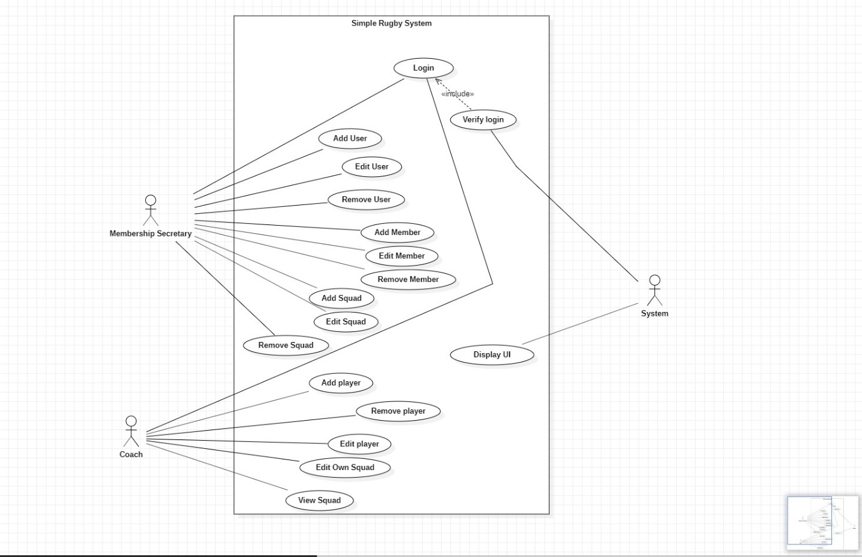

Top level use case with 3 actors. The membership secretary, the coach and the system. The membership secretary and coach can login. The system verifies login and displays the graphical user interface. The membership secretary can add user, edit user, remove user, add member, edit member, remove member, add squad, edit squad, and remove squad. The coach can add player, edit player, remove player, edit own squad, and view own squad.

# Use-case Descriptions

|  |  |
| --- | --- |
| Use Case ID: | T101 |
| Use Case Name: | Login |
| Created by: | Mark McAllister |
| Date Created: | 16/05/2020 |
| Actors: | User, System |
| Trigger: | User wishes to log in |
| Pre-conditions: | User is in system |
| Post-conditions: | Menu displays |
| Normal Flow: | 1. User enters username 2. User enters password 3. If incorrect/invalid info entered 4. Invalid message displayed 5. If 4 attempts or more app closes 6. If correct username and password for user entered 7. Correct menu displayed from user type |
| Extends (Alternative flows): |  |
| Includes: | Verify Login |

|  |  |
| --- | --- |
| Use Case ID: | T102 |
| Use Case Name: | Add User |
| Created by: | Mark McAllister |
| Date Created: | 16/05/2020 |
| Actors: | User, System |
| Trigger: | Coach user needing to be added |
| Pre-conditions: | User not in system |
| Post-conditions: | User created of coach type |
| Normal Flow: | 1. Admin user selects add user from menu 2. Admin enters first name, last name, username, password and selects user type 3. If incorrect/invalid info entered 4. Invalid message displayed 5. If username already on system 6. Username taken message displayed 7. If valid first name, last name username, password and user type selected as coach 8. Coach User added to system |
| Extends (Alternative flows): |  |
| Includes: |  |

|  |  |
| --- | --- |
| Use Case ID: | T103 |
| Use Case Name: | Edit User |
| Created by: | Mark McAllister |
| Date Created: | 16/05/2020 |
| Actors: | User, System |
| Trigger: | User wishes to update information |
| Pre-conditions: | User has had a change in their information |
| Post-conditions: | User information updated |
| Normal Flow: | 1. Admin user selects edit user from menu 2. Admin selects user and clicks to view user information from dropdown list of users 3. Admin enters new information for selected user 4. If nothing entered in any text field 5. Invalid message displayed 6. If information entered 7. Message displays saying user updated 8. Admin clicks view information on user again 9. User information successfully updated |
| Extends (Alternative flows): |  |
| Includes: |  |

|  |  |
| --- | --- |
| Use Case ID: | T104 |
| Use Case Name: | Delete User |
| Created by: | Mark McAllister |
| Date Created: | 16/05/2020 |
| Actors: | User, System |
| Trigger: | User needs to be deleted from system |
| Pre-conditions: | User exists in system |
| Post-conditions: | User no longer in system |
| Normal Flow: | 1. Admin user selects edit user from menu 2. Admin selects user and clicks to delete user 3. Confirmation box displays 4. If admin clicks no or cancel 5. User not deleted message displays 6. If admin clicks yes 7. If user is last admin user 8. Message displays saying user cannot be deleted 9. If user is coach or there are more than 1 admins 10. Message displays saying user deleted 11. User removed from system |
| Extends (Alternative flows): |  |
| Includes: |  |

|  |  |
| --- | --- |
| Use Case ID: | T105 |
| Use Case Name: | Add Squad |
| Created by: | Mark McAllister |
| Date Created: | 16/05/2020 |
| Actors: | User, System |
| Trigger: | Squad needing to be added to system |
| Pre-conditions: | Squad is not in system |
| Post-conditions: | Squad is in system |
| Normal Flow: | 1. Admin user selects add squad from menu 2. Admin enters squad name, selects coach from dropdown and selects team type of junior or senior 3. System checks to ensure squad does not exist, coach has been selected and team type has been selected 4. If invalid, message displays to enter or select valid information 5. If no coach available, squad cannot be created 6. If all information valid 7. Message displays saying squad has been created 8. Squad added to system |
| Extends (Alternative flows): |  |
| Includes: |  |

|  |  |
| --- | --- |
| Use Case ID: | T106 |
| Use Case Name: | Edit Squad |
| Created by: | Mark McAllister |
| Date Created: | 16/05/2020 |
| Actors: | User, System |
| Trigger: | Squad needing to be edited |
| Pre-conditions: | Squad is in system |
| Post-conditions: | Squad information is updated |
| Normal Flow: | 1. Admin user selects edit squad from menu 2. Admin selects squad from dropdown, clicks view details 3. Squad details display 4. Admin selects coach or enters new team name and submits 5. If no coach selected and no team name entered 6. Invalid message displays 7. If valid 8. Message displays saying squad updated 9. Squad updated to reflect changes made |
| Extends (Alternative flows): |  |
| Includes: |  |

|  |  |
| --- | --- |
| Use Case ID: | T107 |
| Use Case Name: | Delete Squad |
| Created by: | Mark McAllister |
| Date Created: | 16/05/2020 |
| Actors: | User, System |
| Trigger: | Squad needing to be removed from system |
| Pre-conditions: | Squad is in system |
| Post-conditions: | Squad is no longer in system |
| Normal Flow: | 1. Admin user selects edit squad from the menu 2. Admin selects squad, clicks delete button 3. Confirmation box displays 4. If admin clicks no or cancel 5. Squad not deleted message displays 6. If admin clicks yes 7. Message displays saying squad removed 8. Squad removed from system |
| Extends (Alternative flows): |  |
| Includes: |  |

|  |  |
| --- | --- |
| Use Case ID: | T108 |
| Use Case Name: | Add Player |
| Created by: | Mark McAllister |
| Date Created: | 16/05/2020 |
| Actors: | User, System |
| Trigger: | Player needs to be added to system |
| Pre-conditions: | Player is not in system |
| Post-conditions: | Player is in system |
| Normal Flow: | 1. Coach user selects add player from menu 2. Coach enters player first name, last name, SRU number, selects position, selects player type and enters guardian name if a junior 3. System checks to ensure player does not already exist, details are entered, and position and player type are selected 4. If invalid, message displays to enter or select valid information 5. If all information valid 6. Message displays saying player has been created 7. Player added to system |
| Extends (Alternative flows): |  |
| Includes: |  |

|  |  |
| --- | --- |
| Use Case ID: | T109 |
| Use Case Name: | Edit Player |
| Created by: | Mark McAllister |
| Date Created: | 16/05/2020 |
| Actors: | User, System |
| Trigger: | Player needs to be altered |
| Pre-conditions: | Player is in system |
| Post-conditions: | Player details changed |
| Normal Flow: | 1. Coach user selects edit player from menu 2. Coach selects player and clicks view information 3. Player info and skills displayed 4. Coach selects skill ratings and enters notes for each skill and clicks submit 5. System checks to make sure valid information 6. If invalid message displays to ensure correct player is being edited 7. If valid 8. Message displays saying player updated 9. Player updated |
| Extends (Alternative flows): |  |
| Includes: |  |

|  |  |
| --- | --- |
| Use Case ID: | T110 |
| Use Case Name: | Delete Player |
| Created by: | Mark McAllister |
| Date Created: | 16/05/2020 |
| Actors: | User, System |
| Trigger: | Player needs to be removed from system |
| Pre-conditions: | Player is in system |
| Post-conditions: | Player removed from system |
| Normal Flow: | 1. Coach user selects edit player from menu 2. Coach selects player and clicks view information 3. Coach clicks delete 4. Confirmation box displays 5. If coach clicks no or cancel 6. Player not deleted message displays 7. If coach clicks yes 8. Message displays saying player removed 9. Player removed from system |
| Extends (Alternative flows): |  |
| Includes: |  |

# Detailed Class Diagram

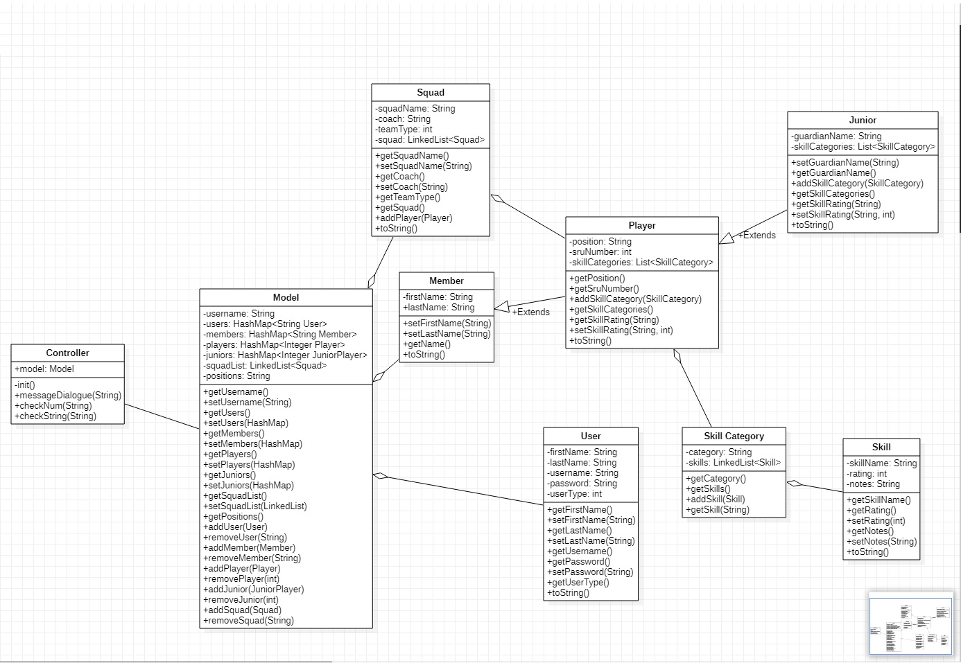

This is a detailed class diagram showing the relationship between all the non-view classes in the app, the data stored in them and the methods in them.

# Add Player Activity Diagram

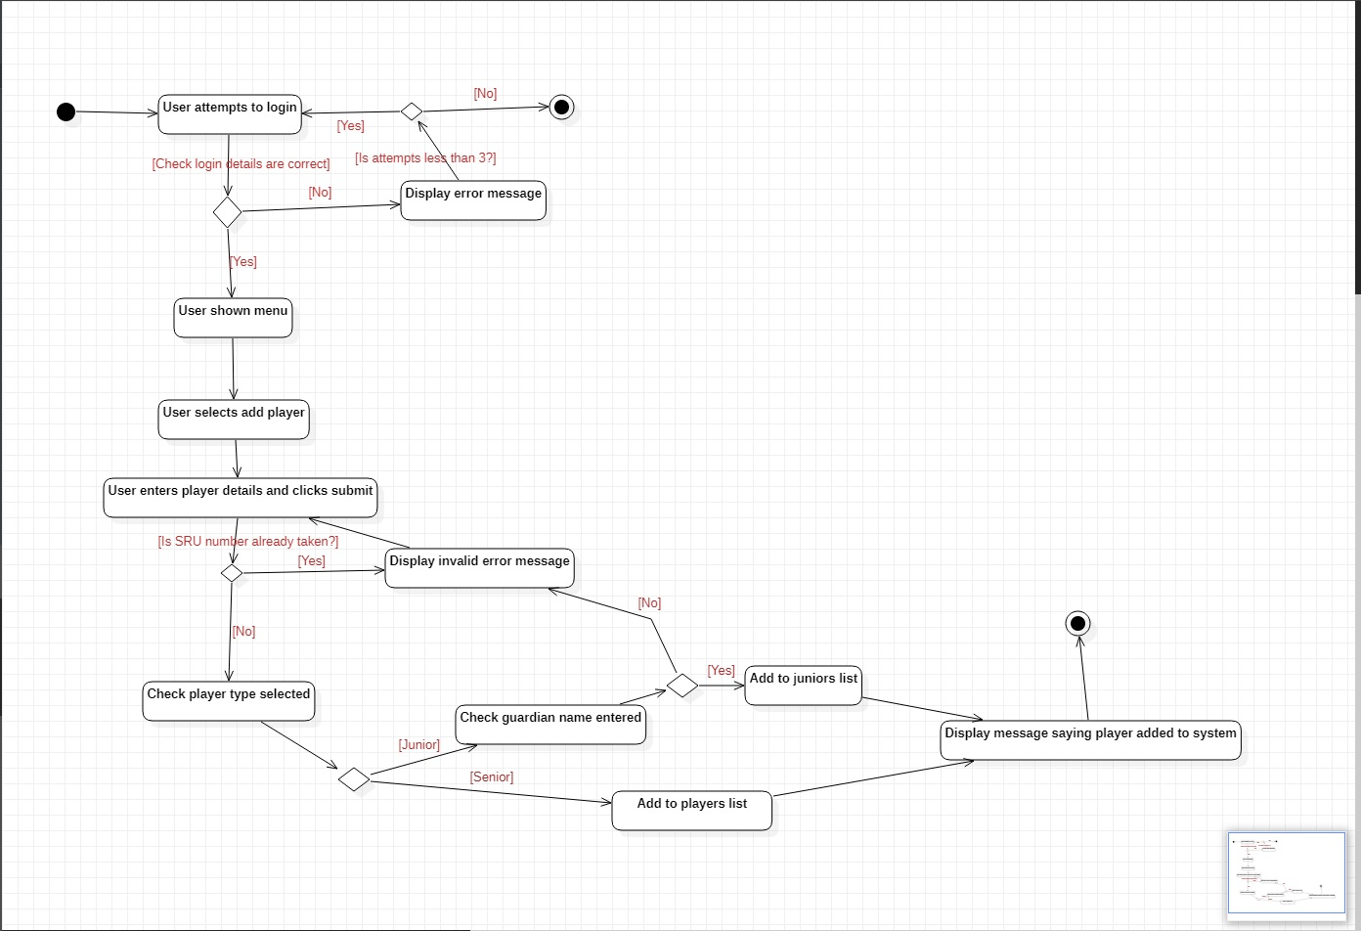

User enters details to login, check occurs to validate user. If invalid, error message displays and if attempts are greater than 3 app closes. If valid, menu displays. User selects to add player and enters player details. System checks if SRU number entered is already taken and displays error message if it is. If not, it checks the player type selected. If a junior player, check occurs to see if guardian name entered. If no guardian name entered, error message displays, player not added to system. If a guardian name entered, player added to juniors list and confirmation message displays. If a senior player, they are added to player list and confirmation message displays.

# Views Wireframes with Descriptions

Click to see full PDF of wireframes and descriptions.

